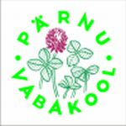 Invitation! 3.-9.june 2015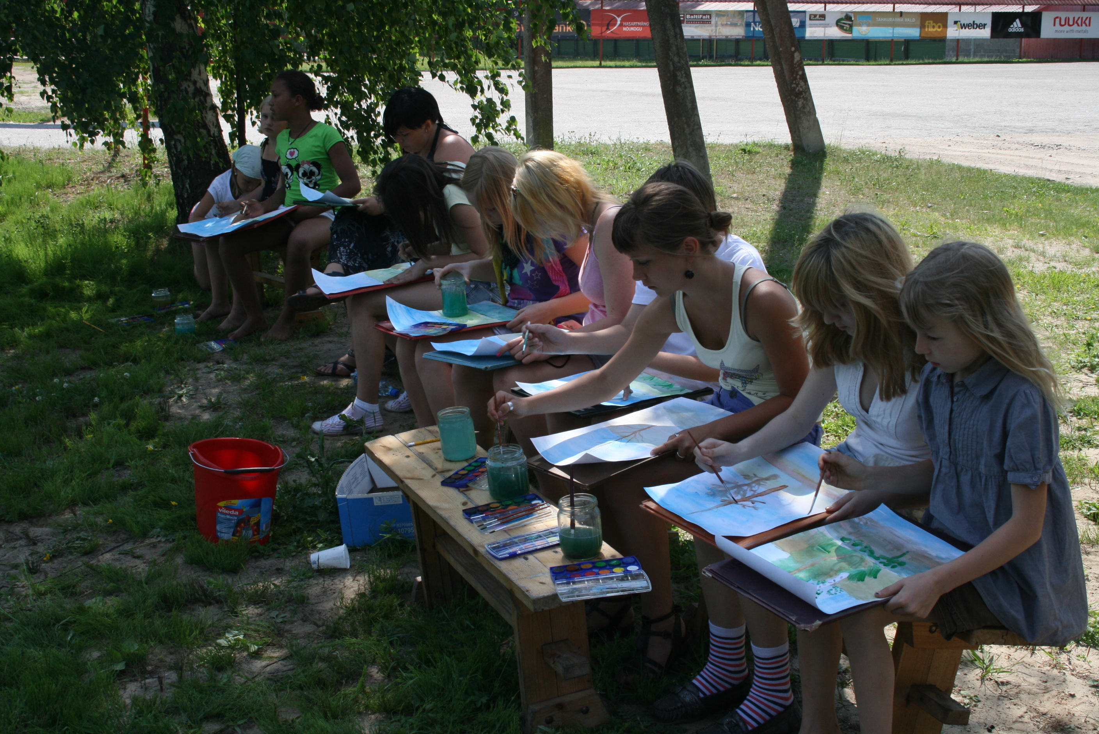 Dear Friends! The Summer Creativity Camp Awaits You!
Summer Creativity Camp, Pärnu Vabakool, Estonia Theme: ART Age Group : 5th-8th graders Group Size : 10 –20 Students + Teacher/parent
Goal : The creativity camp helps children to make connections with other members of the camp, participate in the workshops, get to know foreign countries and cultures in an international enviornment where the communcation language is english. It also helps students to be open minded, entreprenueal, find new friends, create art together and learn new work methods and skills to prepare themselves for thier upcoming invidividual life. The workshops include students from diffrent nations and the communcation will be in English. With other activites the creativity camp pariticpates will also take part in the sand sculpture exhibiton which includes the entire city. The creativty camp ends with a joint art exhibition at Port Artur.
Importantce: At Vabakool freedom of thinking and to act is highly valued. It is important to Vabakool that students are responsible and have the ability to work together responsibly. The International Creativity Camp will teach the students to handle an international environment, help to develop teamwork, creativity , and deepen the ambitions and the cultural-educational knowldge.
As the result of the camp connections between foreign students and teachers will be made.
Accomondation and catering: During the the camp we shall be living in cabins which are located in a naturally beautiful place 25km from Pärnu. Special requests in catering (vegetarians, allergies)should be added to the special requests column in the current questionaire.
Participation fee: 150 EUR covers everything including accomodation at the camp, 3 meals per day, art supplies, exhibit visits and excursions. Payment will take place upon arrival of the camp.
Please send the filled questionaire to kauni.sillat@vabakool.ee latest on 05.march 2015. If you have any questions please don’t hesitate to call 003725131060 or e-mail.
We will be waiting for you Your Vabakool. Estonia www.vabakool.ee
